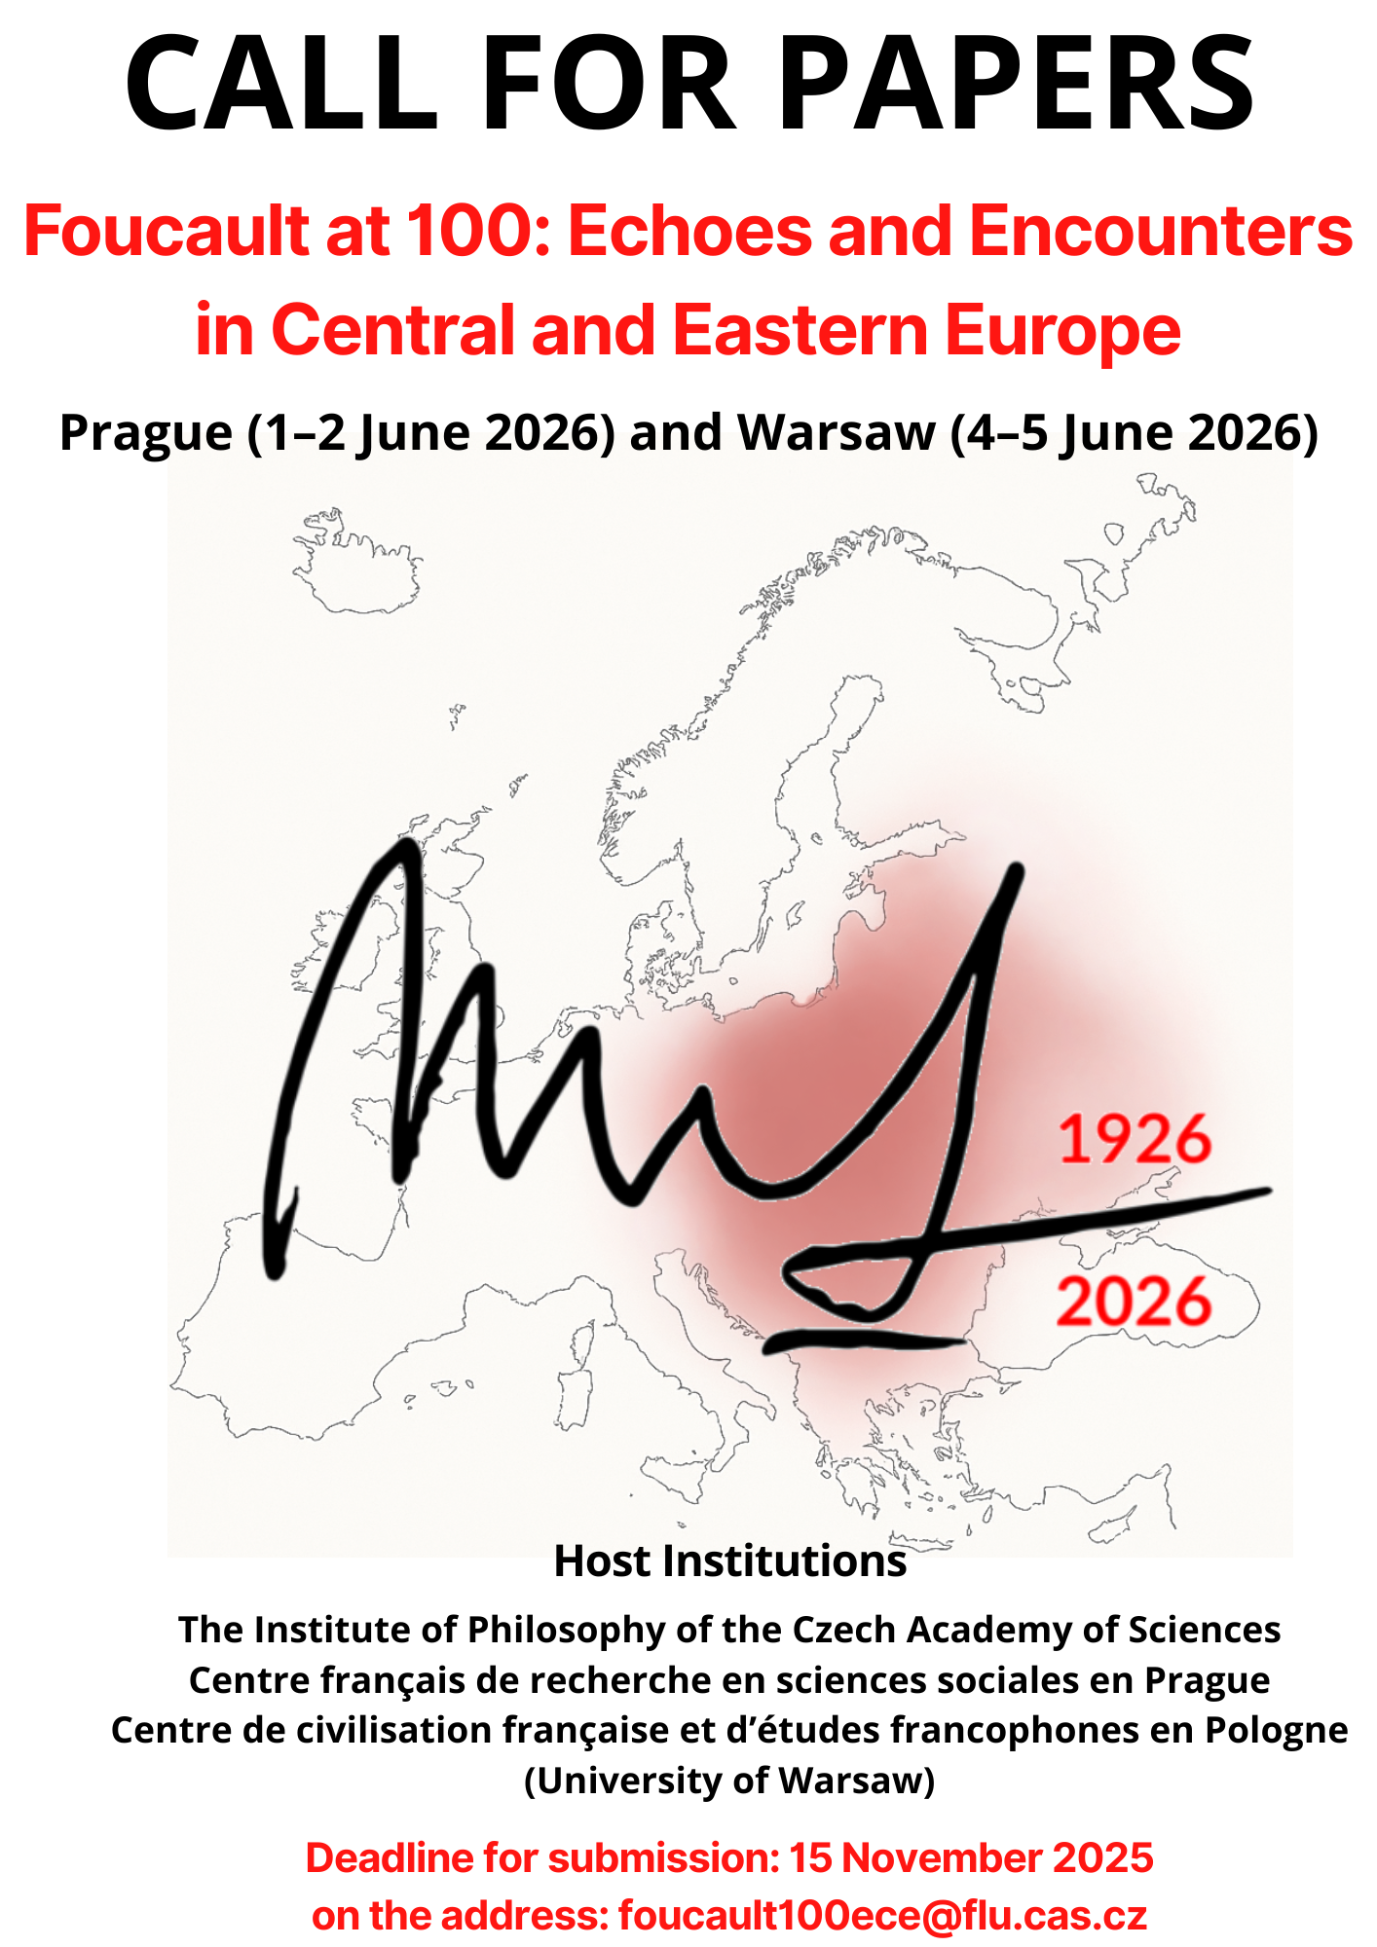
Foucault at 100: Echoes and Encounters in Central and Eastern Europe
Prague (1–2 June 2026) and Warsaw (4–5 June 2026)

Deadline for proposals: 15 November 2025

How can a persisting and truly global interest in Foucault’s thought – from Europe to Japan, through the United States and Brazil – be explained? To become the eloquent and inventive critic of the many projects associated with the “Western” world to which he belonged, Foucault had to first grapple with the elusive outlines of modern thought. By criticizing approaches that tried to present “the subject” as a clear object of study, and instead highlighting those that sought to explore the different practices of subjectification, he made “others” understandable to the “West” – and the “West” understandable to the rest of the world. However, the relationship between Foucault’s works and the “West” – its canon and its various intellectual endeavors – is far from straightforward.
One particular place where this question can be fruitfully asked is Central and Eastern Europe (CEE), where Foucault stayed for some years at the beginning of his career (he worked on his thesis, later published as The History of Madness, in Warsaw in 1958), and where his works enjoyed lasting influence among scholars and intellectuals. The question remains open as to whether, and to what extent, Foucault’s conceptual tools can be applied beyond so-called “Western Europe”, the primary context of his reflections. Were Foucault-inspired analyses carried out in CEE liable to produce a distorted image of the region? And how might rethinking Foucault from the vantage point of CEE shift our perception on both his oeuvre and the so-called “West”? Finally, how was Foucault’s own thinking shaped by CEE thought and his encounters with the region?
Over the past thirty years, scholars both from CEE countries and those working on issues related to this area have produced numerous books, articles, and studies influenced, either primarily or partially, immediately or mediated by Foucauldian perspectives, which opened up conceptually new horizons. Many of these publications have become benchmarks in their respective disciplines (Maria Todorova, Alexei Yurchak, Stephen Kotkin, Stephen J. Collier, and many others). What were the reasons for this interest? As Foucault’s popularity in CEE coincided with major political upheavals and new challenges, could this reception be considered a search for intellectual alternatives to the political thought which supposedly undergirded previous communist regimes? Was it hoped that Foucault’s thought could provide a new social perspective? Was he supposed to inspire academics from Central Europe in their concerted retreat from Marxism-Leninism?
It appears that the vicissitudes of the reception of Foucault in the CEE context give rise to a paradox: though Foucault militated against system-building, insofar as he was cast as a promising alternative to the former keystones of social theory, he became inducted to academic textbooks as a classic of social thought even more surely than in France. Who, and with what intent, were the intellectual actors in introducing him to the academic communities in the region, by way of translations, special issues of academic journals or textbooks? Furthermore, our symposium aims to inquire about the particular modes of Foucault’s reception in CEE academia, as well as in public discourse and activism. What were the intermediaries, the channels, and the ‘stopovers’ on the way by which his thought travelled to CEE? Was it a Foucault from Paris or Berkeley, a Foucault in French, English, German, or Italian? Might it have been Rabinow’s or Agamben’s Foucault?
Whatever the reason for Foucault's pervasive presence, it may not be an exaggeration to say that sometimes scholars from the region draw on Foucault’s ideas without even realizing it. His influence is so deeply embedded in academic discourse that some of his concepts have migrated in various fields where they are used almost uncritically. In our view, a more comprehensive reflection on Foucault’s methodologies and their application to CEE issues has yet to be thoroughly undertaken. Hegel – Foucault’s philosophical archenemy, whose influence he never entirely escaped – argued that any method worthy of the name must, to some extent, follow the activity of the object itself rather than imposing a framework upon it. Foucault, too, embraced this perspective, adapting his approach to suit the problem at hand rather than forcing reality into predetermined structures. This is a crucial lesson to keep in mind when transferring ideas and concepts from one cultural and social context to another. While such a transfer is certainly possible, the transformative work it requires is far less obvious and considerably more demanding.
In this regard, the 100th anniversary of Foucault’s birth presents a unique opportunity to reflect on past contributions, current developments, and future directions of Foucauldian approaches to CEE issues. As the event is the result of a collaborative effort between three institutions across two cities, we have decided to divide it between Prague and Warsaw. The first two days will take place in Prague, followed by a break before continuing in Warsaw. However, this division is not only spatial and temporal but also thematic. Prague will host participants presenting papers on epistemology, philosophy, gender, and aesthetics, while Warsaw will focus on discussions surrounding power, governmentality, and ethics.
We want to discuss together, for example, but not be strictly limited to, the following topics:
- Critical reflections on how Foucault’s concepts (e.g., power, biopolitics, governmentality) have been applied and transformed in CEE scholarship.
- Evaluations of the strengths, limitations, and effects of Foucauldian methodologies in interpreting CEE social, political and historical realities.
- Methodological challenges of transferring Foucauldian concepts across different cultural and social contexts.
- Prospects for future uses of Foucault’s ideas in CEE contexts: new fields, emerging issues, and conceptual adaptations.
- Dialogues and intersections between Foucault’s approaches and major CEE thinkers (e.g., Gáspár Miklós Tamás, Karel Kosík, Jan Patočka, Witold Kula, Ágnes Heller, Evald Ilyenkov, Zygmunt Bauman, Julia Kristeva).
- Intellectual agents and institutions that mediated Foucault’s reception: translations, academic journals, textbooks, public discourse.
- How CEE intellectual traditions might challenge, supplement, or transform Foucauldian frameworks.
- Foucault’s engagement with the East-West divide; Foucault and the Cold War.

Tentative Schedule
Proposals for papers by 15 November 2025
The proposal should include a short abstract (200 words max.), a title, affiliation and a few lines of biography, and possibly a preference for location if papers fall into both thematic strands: Prague (epistemology, gender, and aesthetics) and Warsaw (power, governmentality, and ethics).
All proposals should be sent directly to: foucault100ece@flu.cas.cz

Host Institutions
The Institute of Philosophy of the Czech Academy of Sciences
Centre français de recherche en sciences sociales en Prague
Centre de civilisation française et d'études francophones en Pologne (CCFEF)

Organizing Committee
Mateusz Chmurski, Isabel Jacobs, Jiří Růžička, Radosław Szymański, Laurent Tatarenko

Contact Email
foucault100ece@flu.cas.cz

